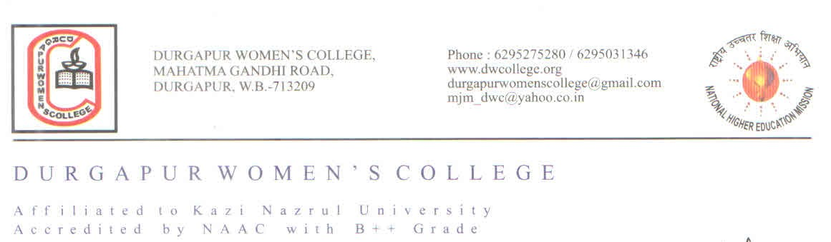

Ref No. ………………………………….. Date : 19th August 2024

**NOTICE**

**The College with all it's Departments will remain fully closed on 24th December 2024 on account of College Social .**

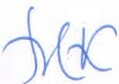

**Dr. Mahananda Kanjilal**

**Principal**

**Durgapur Women’s College**

